
SCHOOL OF ENGINEERING & TECHNOLOGY AND ARTIFICIAL INTELLIGENCE, MNR UNIVERSITY

DEPARTMENT OF COMPUTER SCIENCE & ENGINEERING (Hons/AIML/AIDS)
Lab Tasks
ON
Credit card processing system
(SESSION – 2025-26)
Software crafting & Sculpting

SUBMITTED BY: M.Ramya sri CLASS: B. Tech 1ST Yr IISem
SECTION: A ROLL NO:25RBAIM0005
SUBJECT: Software crafting & Sculpting DEPARTMENT: CSE(AIML)

SUBMITTED TO:
DR.Praveen sir
MNR UNIVERSITY, SANGAREDDY
MNR Nagar, Fasalwadi, Sangareddy District, Gr. Hyderabad -502294, Telangana, India
Task 1: Development of problem statements

Credit card processing system
Problem statement:
Credit Card Processing System is used to manage and process credit card transactions securely and efficiently. This system helps customers make payments using credit cards while allowing banks and merchants to verify transactions quickly. The system reduces manual work, improves transaction speed, and ensures secure handling of financial data.
The core of the system is to process payment requests made by customers using their credit cards. When a customer makes a purchase, the transaction details such as card number, expiry date, and payment amount are sent to the credit card processing system. The system verifies the card information with the bank database and checks whether the card is valid and whether sufficient credit limit is available.
After verification, the system sends an approval or rejection message to the merchant. If the transaction is approved, the payment is completed and recorded in the database. The bank then updates the customer’s credit card account with the transaction details. This system ensures safe, fast, and reliable financial transactions between customers, merchants, and banks.
Here are a few issues with the manual system that could be addressed through the development of a Credit Card Processing System:

Manual Transaction Processing
In manual systems, payment verification and record keeping take a long time. This leads to delays in transaction approval and increases workload for employees.

Security Risks
Handling sensitive credit card information manually can increase the risk of fraud, data theft, and unauthorized access to financial data.

Transaction Errors
Manual entry of card details may lead to mistakes such as incorrect amounts or card numbers, which can cause transaction failures or financial loss.

Slow Transaction Processing
Manual payment systems cannot process transactions instantly, causing delays for customers and merchants during payments.

Lack of Real-Time Verification
Without an automated system, it is difficult to instantly verify card validity, credit limits, or suspicious transactions.

Poor Transaction Tracking
Customers and banks may face difficulties tracking payment history and transaction status without a proper system.

Fraud Detection Challenges
Manual systems cannot easily identify fraudulent activities or unusual transaction patterns, increasing the risk of financial fraud.

Limited Accessibility
Customers cannot make payments easily from different locations without an online or automated payment system.

Inefficient Record Management
Maintaining paper records of credit card transactions makes storage, retrieval, and management difficult.

Lack of Integration with Banking Systems
Manual systems are not integrated with banking databases, which makes transaction verification slow and inefficient.
Task 2: Preparation of Software Requirement Specification Document, Design Documents and Testing Phase related documents
SOFTWARE REQUIREMENT SPECIFICATION (SRS) FOR CREDIT CARD PROCESSING SYSTEM

PURPOSE
If the entire process of credit card payment verification and transaction handling is done manually, it would take a long time and increase the chances of errors and fraud. Considering that the number of credit card users and online transactions is increasing every year, an automated Credit Card Processing System becomes essential.
This system uses software and database technologies to process credit card transactions securely and efficiently. The system verifies card details, processes payments, and records transactions in real time. Since financial transactions involve sensitive data, the system must be carefully designed, verified, and validated to ensure security, reliability, and accuracy.
SCOPE
- The system provides an online interface for customers to make payments using their credit cards.
- Customers can enter their card details, transaction amount, and confirm payments securely.
- The system verifies the card validity, expiry date, and available credit limit with the bank database.
- The system helps merchants receive payment confirmation quickly.
- It provides a communication platform between customers, merchants, and banks.
- The system records all transaction details for future reference and auditing.
- Customers can check their transaction status and payment history.
- The system ensures secure transfer of financial data between banks and merchants.

DEFINITIONS, ACRONYMS AND ABBREVIATIONS
Credit Card: A payment card issued by a bank that allows users to borrow funds to pay for goods or services.
Transaction: The process of transferring payment from a customer to a merchant using a credit card.
Merchant: A business or seller that accepts credit card payments from customers.
Payment Gateway: A technology used to securely transfer transaction information between the customer, merchant, and bank.
Authentication: The process of verifying the identity of the credit card holder before approving the transaction.
Database: A structured collection of data used to store credit card information and transaction records.
Task 3: Preparation of Software Configuration Management and Risk Management related documents.
Software Configuration Management (SCM) Document
Introduction
This document describes the Software Configuration Management process for the Credit Card Processing System. The purpose of this document is to manage and control changes in the system during development. It ensures that all project components such as source code, documents, and design files are properly maintained and updated.
The scope of this document includes version control, change management, configuration identification, and release management for the Credit Card Processing System
Configuration Management Plan
The configuration management plan defines the overall approach used to manage project artifacts.
The development team will maintain all project files in a controlled repository. Each team member will follow proper procedures while modifying source code or documents.
Roles and responsibilities will be assigned to team members to manage configuration activities such as version control, change tracking, and release updates.
Tools such as Git or other version control systems will be used to manage source code and project documents.

Version Control
Version control will be used to manage different versions of the source code and project documents.
Every change in the project will be recorded with a new version number. Branching and merging techniques will be used to allow multiple developers to work on the project simultaneously.
Release versions will be created after successful testing of the Credit Card Processing System.

Configuration Identification
Each component of the Credit Card Processing System such as source code files, design documents, and test documents will have unique identification.
Naming conventions will be followed to ensure easy identification and management of configuration items.
Each version will be labeled clearly with version numbers and release dates.

Configuration Control
Configuration control ensures that all changes to the system are properly reviewed and approved.
Any change request will be submitted to the project team for review. After approval, the change will be implemented and recorded in the configuration management system.
All changes will be documented to maintain transparency in the development process.

Configuration Status Accounting
Configuration status accounting tracks the status of all configuration items.
Reports will be generated to show which versions are currently active and what changes have been made.
These reports help the development team monitor the progress of the Credit Card Processing System.

Configuration Auditing
Configuration auditing ensures that the system follows defined standards and requirements.
Regular audits will be conducted to verify that all project components are correctly maintained and documented.
This helps maintain the quality and reliability of the system.
Baseline Management
Baselines will be created at important stages of the project such as design completion, testing phase, and final release.
Once a baseline is established, any modification must go through the configuration control process.
This ensures that the system remains stable during development.

Backup and Recovery
Regular backups of project files and configuration items will be maintained.
Backup copies will be stored securely to prevent data loss due to system failures or unexpected issues.
Recovery procedures will be followed to restore data when necessary.

Release Management
Release management defines the process of delivering the final software product.
Each release of the Credit Card Processing System will be packaged, tested, and deployed to the production environment.
Proper documentation will be provided with every release.

Risk Management Document

Introduction
Risk management is an important part of the development of the Credit Card Processing System. It helps identify potential risks that may affect the project and provides strategies to reduce or eliminate those risks.
This document explains how risks will be identified, analyzed, and managed during the project lifecycle.

Risk Management Plan
The risk management plan describes the approach used to handle risks in the project.
The project team will continuously monitor potential risks and take necessary actions to minimize their impact.
Responsibilities for risk identification and mitigation will be assigned to team members.

Risk Identification
Possible risks in the Credit Card Processing System include:
- Security breaches in credit card data
- System failure during transaction processing
- Network connectivity issues
- Unauthorized access to financial information
- Software bugs or errors in payment processing
- Delay in system development
- Data loss due to system crashes

Risk Assessment
Each identified risk will be evaluated based on its impact and likelihood.
High-impact risks such as security threats and system failures will be given the highest priority.
A risk matrix will be used to categorize risks as low, medium, or high severity.

Risk Mitigation Strategies
Strategies will be implemented to reduce high-priority risks.
Examples include:
- Implementing strong encryption for credit card data
- Regular system testing to detect software bugs
- Using secure authentication methods
- Performing frequent system backups
- Monitoring network security

Risk Monitoring and Control
Risks will be continuously monitored throughout the project.
The development team will track potential risk triggers and take preventive actions before they affect the system.
Regular meetings will be conducted to review risk status.

Risk Communication
Information about project risks will be communicated clearly to all stakeholders.
Reports and updates will be shared with project managers and team members to ensure transparency.

Contingency Planning
Contingency plans will be prepared for risks that cannot be fully avoided.
For example:
- Backup servers will be used if the main system fails
- Recovery procedures will restore lost data
- Security measures will be activated in case of fraud detection
Lessons Learned
All risk events and solutions will be documented during the project.
These lessons will help improve risk management practices in future projects.
Bottom of Form

4.Study and Usage of a Design Phase CASE Tool on Credit Card Processing System

A Credit Card Processing System performs:
- Card validation
- Transaction authorization
- Payment processing
- Fraud checking
- Settlement and reporting

Main Components
- Customer
- Merchant
- Payment Gateway
- Bank
- Credit Card Network
- Transaction Database

Use of CASE Tool in Design Phase

1. Use Case Diagram
This diagram identifies the actors and system functions.
Actors:
Customer
Merchant
Bank Administrator
Use Cases:
- Make Payment
- Validate Card
- Authorize Transaction 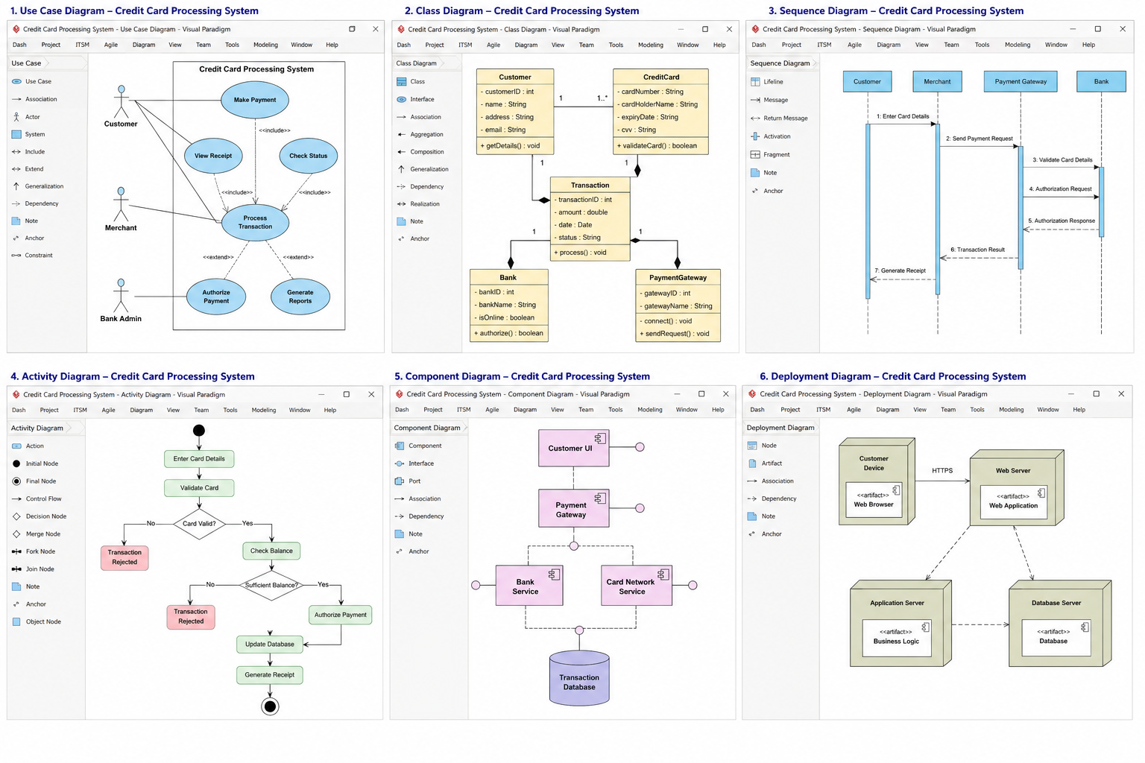
- Generate Receipt
- View Reports

2. Class Diagram
The CASE tool helps create classes and relationships.

Main Classes
Class | Responsibility
Customer | Holds customer information
CreditCard | Stores card details
Transaction | Processes payments
Bank | Verifies and authorizes
PaymentGateway | Connects merchant and bank


3. Sequence Diagram
Shows interaction between system components.

Flow
- Customer enters card details.
- Merchant sends request.
- Payment Gateway validates data.
- Bank authorizes transaction.
- Response returned to merchant.
- Receipt generated.


4. Activity Diagram
Represents workflow of transaction processing.

Activities
- Enter Card Details
- Validate Card
- Check Balance
- Authorize Payment
- Update Database
- Generate Receipt


5. Database Design
CASE tools help design ER diagrams and database schema.

Main Tables
Table | Description
Customer | Customer details
CreditCard | Card information
Transaction | Transaction records
Merchant | Merchant details
Payment | Payment history
5.Preparation and Development of an ER Diagram for a given problem statement using any Design Phase CASE tool.
Main Entities and Attributes
- Customer
Attributes:
Customer_ID (Primary Key)
Name
Address
Phone_Number
Email
Date_of_Birth
- Credit_Card
Attributes:
Card_Number (Primary Key)
Card_Type
Expiry_Date
CVV
Credit_Limit
Available_Balance
Customer_ID (Foreign Key)
3. Bank_Account
Attributes:
Account_Number (Primary Key)
Bank_Name
Account_Type
Balance
Customer_ID (Foreign Key)
4. Transaction
Attributes:
Transaction_ID (Primary Key)
Transaction_Date
Amount
Transaction_Status
Merchant_ID (Foreign Key)
Card_Number (Foreign Key)
5. Merchant
Attributes:
Merchant_ID (Primary Key)
Merchant_Name
Location
Merchant_Type
6.Payment
Attributes:
Payment_ID (Primary Key)
Payment_Date
Amount_Paid
Account_Number (Foreign Key)
Card_Number (Foreign Key)
7. Billing
Attributes:
Bill_ID (Primary Key)
Bill_Date
Due_Date
Total_Amount
Card_Number (Foreign Key)

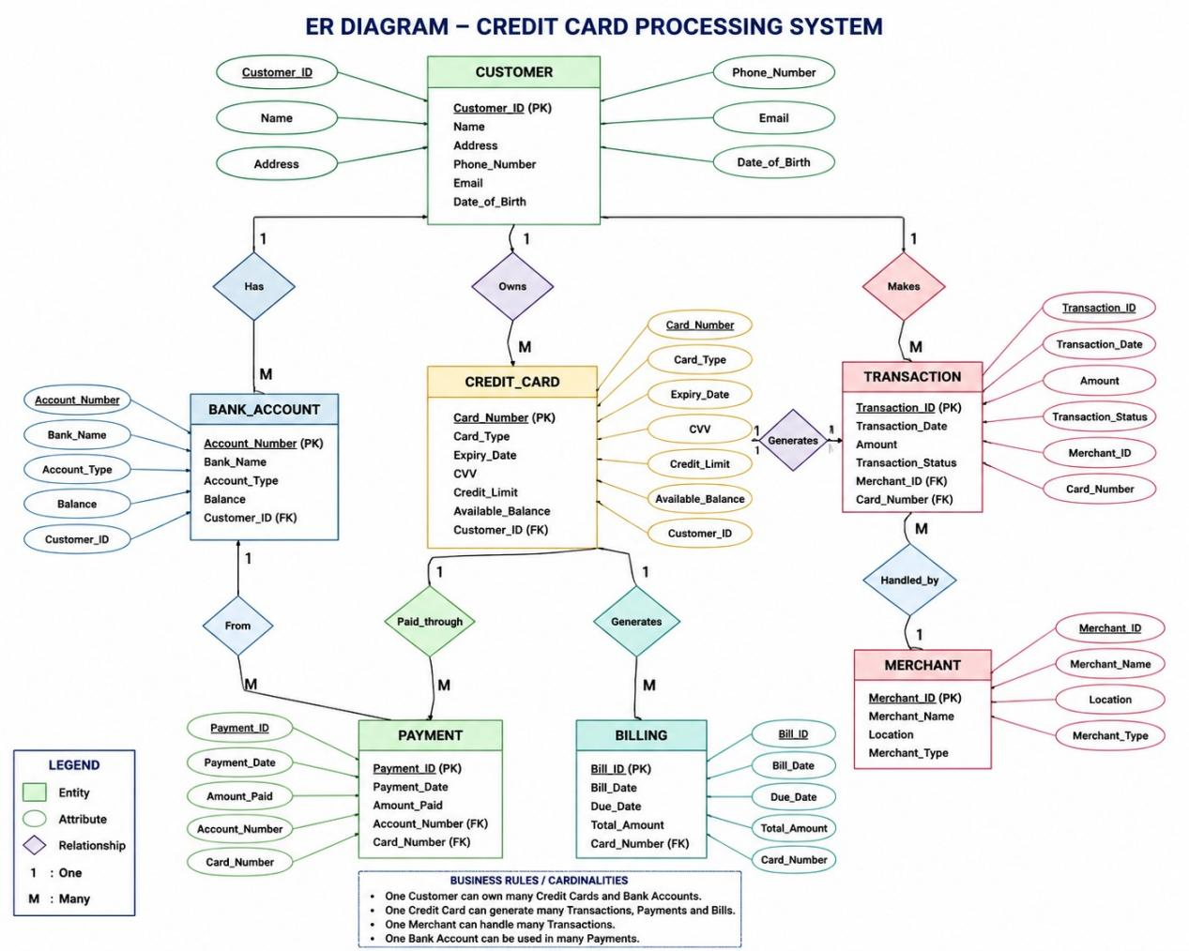
- Preparation and Development of Data Flow Diagrams (DFD) including Context Diagram, Level 0 DFD, and Level 1 DFD for a given system using any Design Phase CASE tool on credit card processing system.
A Data Flow Diagram (DFD) represents how data moves through a system. The following DFDs are prepared for a Credit Card Processing System using a design-phase CASE tool approach (such as Rational Rose, Visual Paradigm, StarUML, Lucidchart, or Draw.io).

1. System Description: Credit Card Processing System
The system manages:
- Customer credit card applications
- Card verification
- Transaction processing
- Payment authorization
- Billing and account updates
- Transaction records

External Entities:
Customer
Merchant
Bank / Payment Gateway
Credit Card Company
Administrator

Data Stores:
Customer Database
Card Account Database
Transaction Database
Payment Database

1. Context Diagram (Level 0 Context DFD)
A context diagram shows the entire system as a single process and its interaction with external entities.

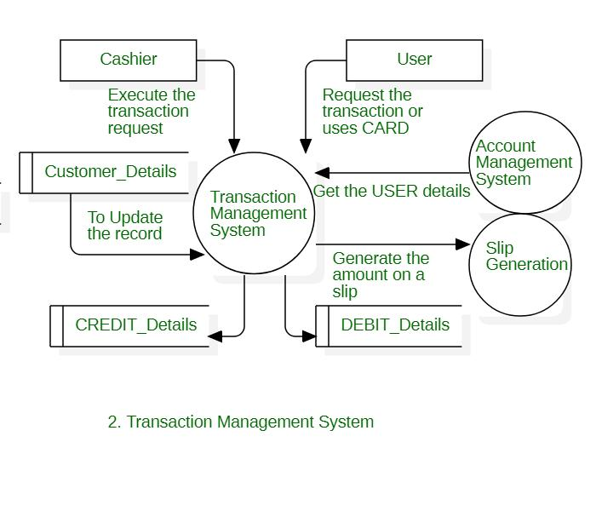
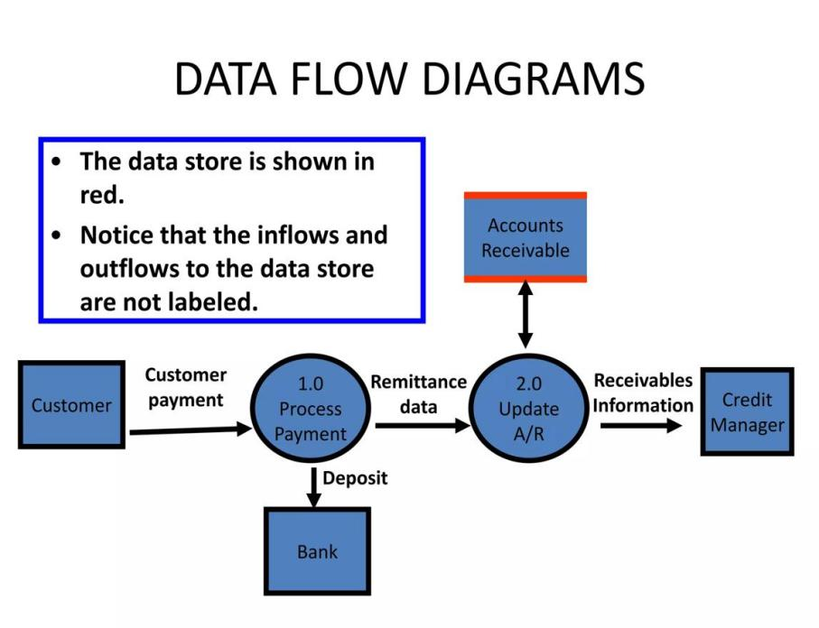

2. Level 0 DFD (Main Processes)
Level 0 DFD decomposes the system into major processes.

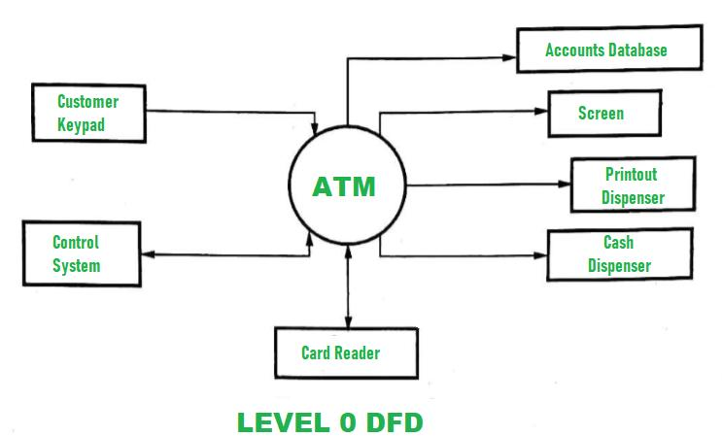

3.Level 1 DFD (Detailed Transaction Processing)
Level 1 DFD provides detailed flow inside major processes.
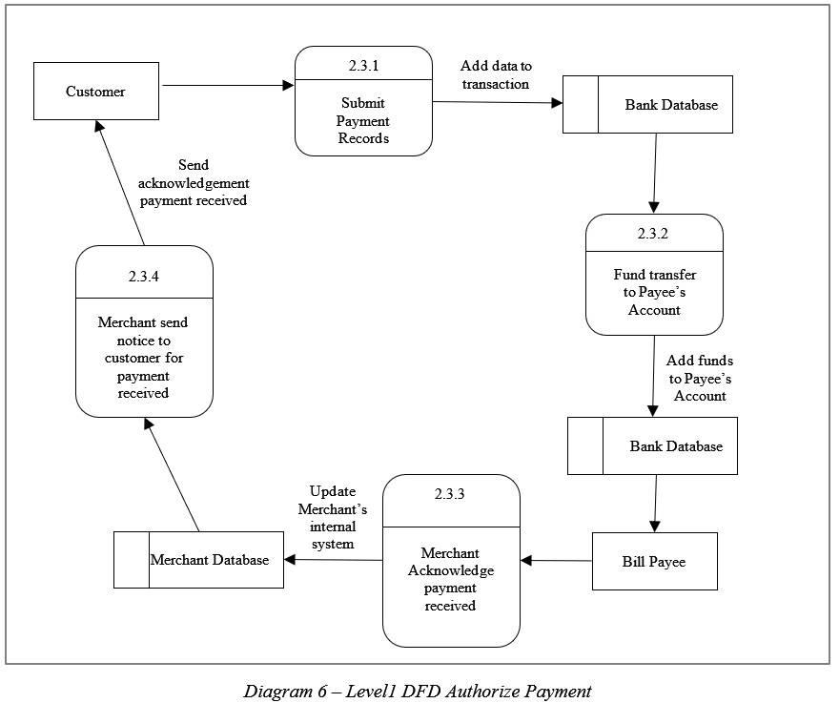
7.Performing the Structural Design using any Design Phase CASE tool on credit card processing system.
Structural Design describes the architecture of a software system by identifying its major components, modules, classes, databases, and relationships. For a Credit Card Processing System, structural design can be created using CASE tools such as:
- Visual Paradigm
- StarUML
- Rational Rose
- Draw.io
The structural design includes:
Class Diagram
Component Diagram
Database Structure

1. Class Diagram for Credit Card Processing System
A class diagram represents the static structure of the system by showing classes, attributes, operations, and relationships.
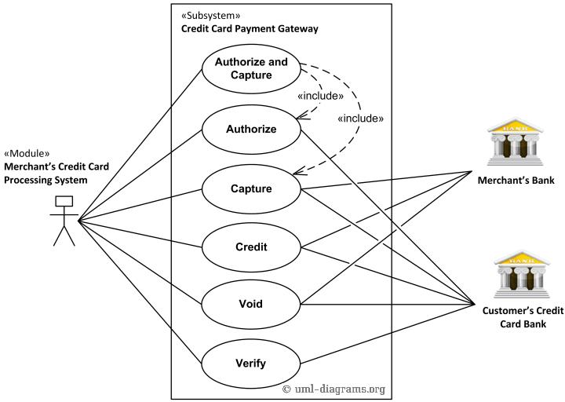

8.Performing the Behavioral Design using any Design Phase CASE tool.

Behavioral Design describes how a system behaves over time, including interactions between users, objects, and processes. It focuses on the dynamic aspects of the Credit Card Processing System.

State Diagram
A state diagram shows different states of a credit card during its lifecycle.
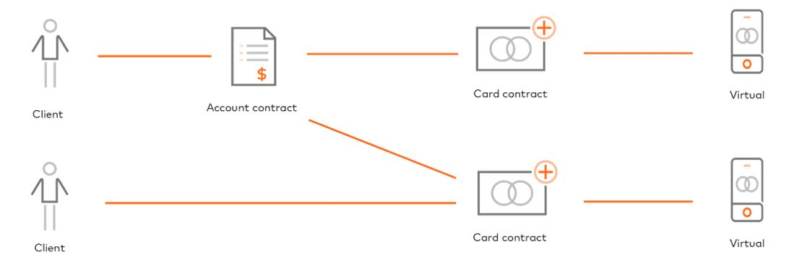
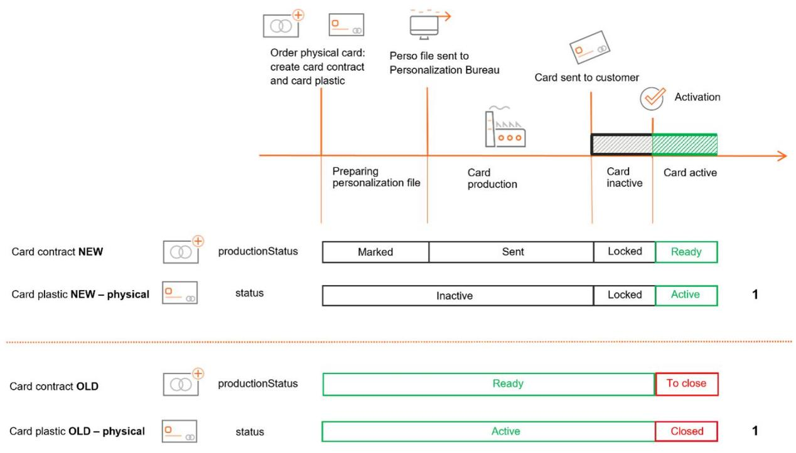
9.Study and Usage of Software Testing Tool (Selenium) for Performing Functional and Automated Testing

Application: Credit Card Processing System

1. Introduction to Selenium
Selenium is an open-source automation testing tool used for testing web applications. It automates browser actions and is widely used for functional testing and regression testing.
Selenium supports multiple programming languages such as:
- Java
- Python
- C#
- JavaScript
For testing the Credit Card Processing System, Selenium is used to automate operations like:
- User login
- Credit card application
- Card validation
- Transaction processing
- Payment confirmation
- Report generation

2. Selenium Components

1. Selenium WebDriver
Controls the browser automatically.
Performs actions such as clicking, typing, and navigation.

2. Selenium IDE
- Browser extension used for recording and playing test cases.

3. Selenium Grid
- Executes tests on multiple browsers and operating systems.

Selenium IDE Test Output
The Selenium IDE execution shows:
- Test Case: Credit Card Login
- Test Steps Executed: 8
- Passed Tests: 1
- Failed Tests: 0
- Success Rate: 100%

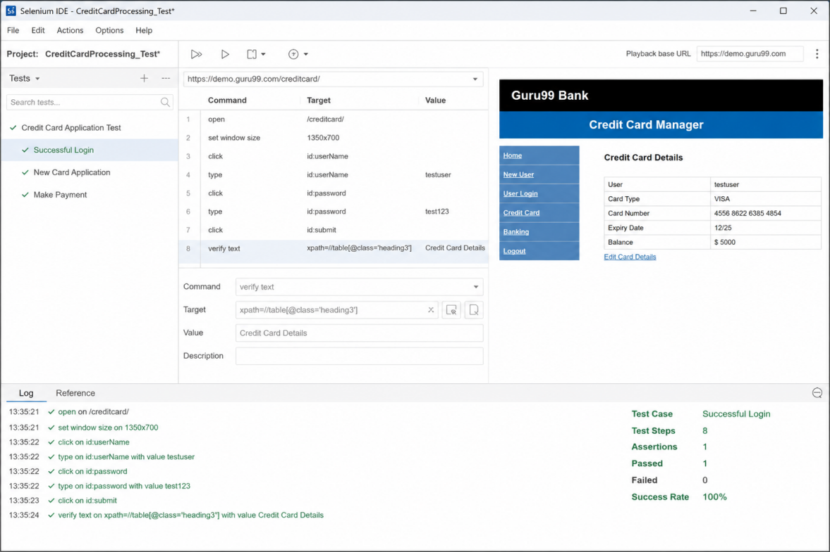
10.Develop test cases for Unit Testing and Integration Testing

A) Unit Testing Test Cases

Module 1: Customer Registration
Test Case ID | Test Scenario | Test Input | Expected Result | Actual Result | Status
UT_001 | Verify customer registration with valid details | Name, Email, Phone | Customer account created successfully | Account created | Pass
UT_002 | Register with empty fields | Blank name/email | Error message displayed | Error displayed | Pass
UT_003 | Verify email validation | Invalid email format | Invalid email warning shown | Warning shown | Pass

Module 2: Credit Card Validation
Test Case ID | Test Scenario | Test Input | Expected Result | Actual Result | Status
UT_004 | Check valid card number | 16-digit card number | Card accepted | Card accepted | Pass
UT_005 | Check invalid card number | Incorrect card number | Card rejected | Rejection displayed | Pass
UT_006 | Verify expiry date | Expired card date | Expired card message displayed | Message displayed | Pass

Module 3: Transaction Processing
Test Case ID | Test Scenario | Test Input | Expected Result | Actual Result | Status
UT_007 | Process valid transaction | Amount = ₹5000 | Transaction completed | Completed | Pass
UT_008 | Process zero amount transaction | Amount = ₹0 | Error message displayed | Error displayed | Pass
UT_009 | Check transaction status update | Successful payment | Status changed to "Completed" | Updated | Pass

Module 4: Payment Processing
Test Case ID | Test Scenario | Test Input | Expected Result | Actual Result | Status
UT_010 | Make successful payment | Valid card + amount | Payment accepted | Accepted | Pass
UT_011 | Payment with blocked card | Blocked card details | Payment rejected | Rejected | Pass
UT_012 | Generate payment receipt | Completed payment | Receipt generated | Generated | Pass

B) Integration Testing Test Cases
Integration testing checks communication between system modules.

Integration Test 1: Customer Module + Card Module
Test Case ID | IT_001
Scenario | Verify customer registration with card creation
Input | Customer details and card application
Modules Tested | Customer Module + Card Management Module
Expected Result | Customer account and card details stored successfully
Result | Pass

Integration Test 2: Card Module + Transaction Module
Test Case ID | IT_002
Scenario | Verify transaction using valid credit card
Input | Card number, expiry date, purchase amount
Modules Tested | Card Validation + Transaction Processing
Expected Result | Card verified and transaction processed
Result | Pass

Integration Test 3: Transaction Module + Bank Gateway
Test Case ID | IT_003
Scenario | Verify payment authorization
Input | Transaction request
Modules Tested | Transaction System + Bank Authorization
Expected Result | Bank returns approval/decline response
Result | Pass

Integration Test 4: Transaction Module + Payment Module
Test Case ID | IT_004
Scenario | Generate payment record after successful transaction
Input | Completed transaction details
Modules Tested | Transaction Processing + Payment Processing
Expected Result | Payment record and receipt generated
Result | Pass

Integration Test 5: Payment Module + Reporting Module
Test Case ID | IT_005
Scenario | Generate customer transaction report
Input | Payment history
Modules Tested | Payment Database + Report Generation
Expected Result | Correct transaction report displayed
Result | Pass

- Develop test cases for various White Box and Black Box Testing techniques.

A) White Box Testing Techniques

1. Statement Coverage Testing
Purpose:
Ensures that every statement in the program is executed at least once.

Module: Credit Card Validation

Test Cases:
Test Case ID | Input | Expected Output | Coverage
WB_001 | Valid card number | Card Accepted | Executes IF statement
WB_002 | Invalid card number | Invalid Card | Executes ELSE statement

2. Branch Coverage Testing
Purpose:
Tests all possible decision outcomes (True/False branches).

Test Cases:
Test Case ID | Condition | Input | Expected Result
WB_003 | Card status = Active | Active card | Transaction allowed
WB_004 | Card status = Blocked | Blocked card | Transaction rejected

3. Path Coverage Testing
Purpose:
Tests all possible execution paths in the program.

Test Cases:
Test Case ID | Path | Input | Result
WB_005 | Valid card → Payment | Valid card details | Payment completed
WB_006 | Invalid card → Reject | Wrong card details | Payment failed

. Loop Testing
Purpose:
Tests loops for correct execution.

Example:
Checking multiple transaction records.

Test Cases:
Test Case ID | Number of Transactions | Expected Result
WB_007 | 0 transactions | No records displayed
WB_008 | 1 transaction | One record displayed
WB_009 | 100 transactions | All records processed

Condition Testing

Purpose:
Tests individual conditions in decision statements.

B) Black Box Testing Techniques

1. Equivalence Partitioning
Purpose:
Divides input data into valid and invalid groups.

Example: Transaction Amount
Partition | Input Range | Expected Result
Valid | ₹1 - ₹50000 | Transaction accepted
Invalid | ₹0 | Error message
Invalid | Above ₹50000 | Limit exceeded

Test Cases:
Test Case ID | Input Amount | Expected Output
BB_001 | ₹5000 | Payment successful
BB_002 | ₹0 | Invalid amount
BB_003 | ₹60000 | Transaction rejected

2. Boundary Value Analysis
Purpose:
Tests values at the boundary limits.

Example: Credit Card PIN Length
Valid range: 4 digits
Test Case ID | Input | Expected Result
BB_004 | 3 digits | Invalid PIN
BB_005 | 4 digits | Accepted
BB_006 | 5 digits | Invalid PIN

State Transition Testing
Purpose:
Tests system behavior when states change.

Credit Card States:
Applied → Active → Blocked → Reactivated → Active

Test Cases:
Test Case ID | Current State | Action | Next State
BB_010 | Applied | Approval | Active
BB_011 | Active | Fraud detected | Blocked
BB_012 | Blocked | Verification completed | Active


SCHOOL OF ENGINEERING & TECHNOLOGY AND ARTIFICIAL INTELLIGENCE, MNR UNIVERSITY

DEPARTMENT OF COMPUTER SCIENCE & ENGINEERING (Hons/AIML/AIDS)
Mini project Report
ON
Credit card processing system
(SESSION – 2025-26)
Software crafting & Sculpting

SUBMITTED BY: M.Ramya sri CLASS: B. Tech 1ST Yr IISem
SECTION: A ROLL NO:25RBAIM0005
SUBJECT: Software crafting & Sculpting DEPARTMENT: CSE(AIML)

SUBMITTED TO:
DR.Praveen sir
MNR UNIVERSITY, SANGAREDDY
MNR Nagar, Fasalwadi, Sangareddy District, Gr. Hyderabad -502294, Telangana, India

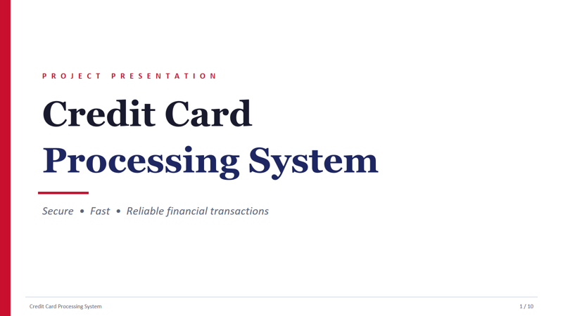

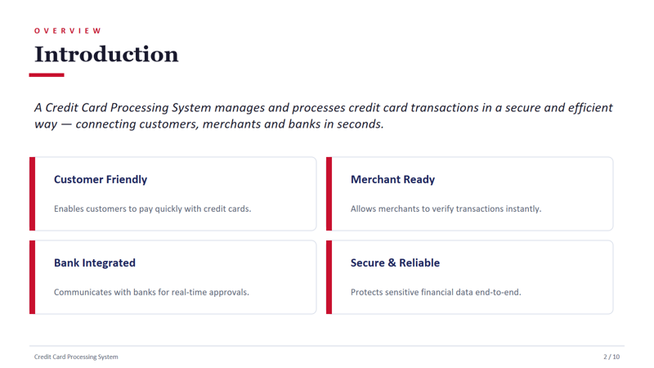

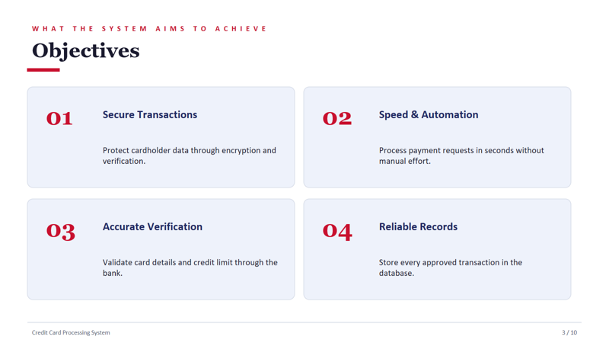

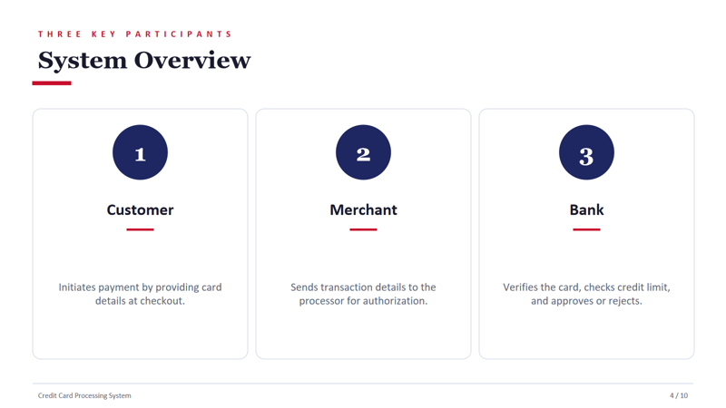

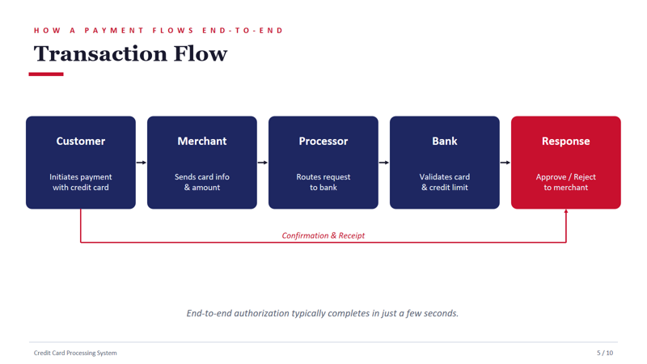

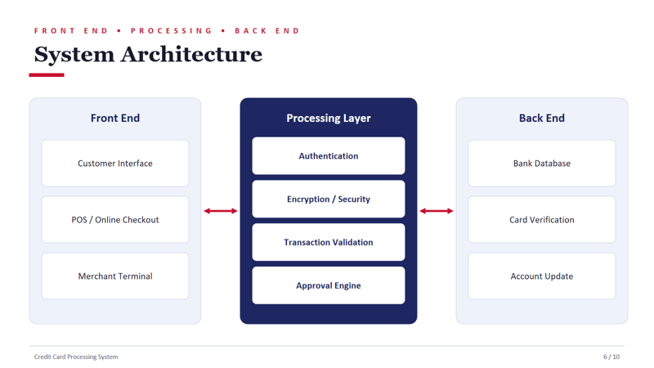

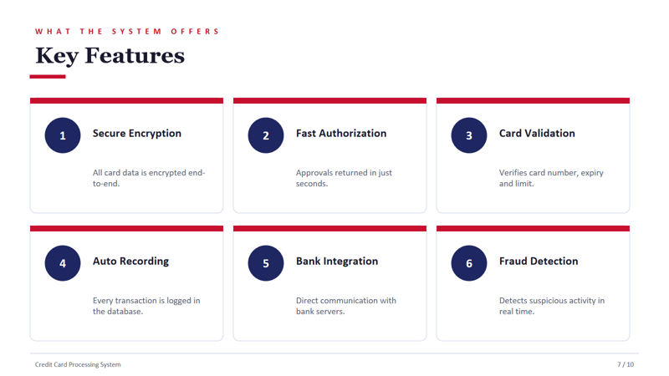

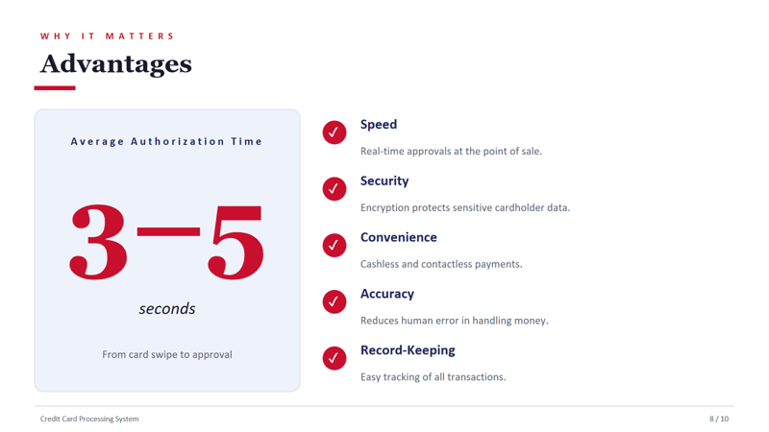

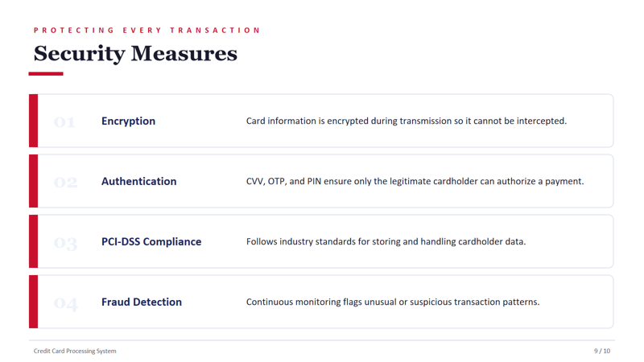

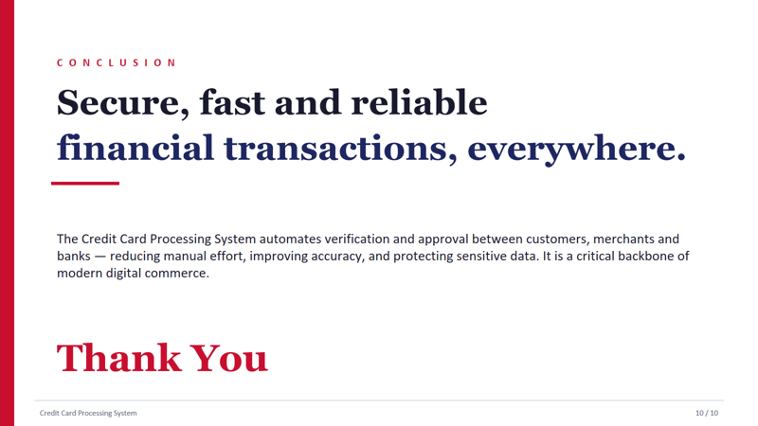

Credit Card Processing System

1. Requirements Engineering

1.1 Problem Statement
A Credit Card Processing System is developed to securely process card transactions between customers, merchants, and banks. The system validates card details, checks available credit, authorizes transactions, detects fraud, and maintains payment records.

1.2 Functional Requirements

Customer Functions
- User registration and login
- Add/manage credit cards
- Make payments using credit card
- View transaction history
- Receive payment notifications

Merchant Functions
- Merchant login
- Accept card payments
- View payment reports

Admin Functions
- Manage users and merchants
- Monitor transactions
- Detect suspicious transactions
- Generate reports

Payment Processing Functions
- Card validation
- PIN/OTP authentication
- Credit limit verification
- Transaction authorization
- Payment confirmation

1.3 Non-Functional Requirements
Requirement | Description
Security | Data encryption and secure authentication
Performance | Process transactions within 3–5 seconds
Reliability | 99.9% system uptime
Scalability | Handle large transaction volumes
Availability | 24/7 service availability
Maintainability | Easy debugging and updates

1.4 Software Requirements Specification (SRS)

User Requirements
- Users can make secure payments.
- Merchants can receive payments.
- Admin can monitor transactions.

System Requirements
- Database to store customer/card details.
- Payment gateway integration.
- Fraud detection mechanism.
- Secure login system.

Interface Specifications

User Interface
- Login Page
- Payment Page
- Transaction History Page

Hardware Interface
- Payment terminal/card reader

Software Interface
- Database (MySQL)
- Banking API
- OTP Service

2. System Modeling

2.1 Use Case Diagram

Actors:
- Customer
- Merchant
- Admin
- Bank Server

Use Cases:
- Register/Login
- Add Card
- Make Payment
- Verify OTP
- View Transactions
- Monitor Transactions
- Generate Reports

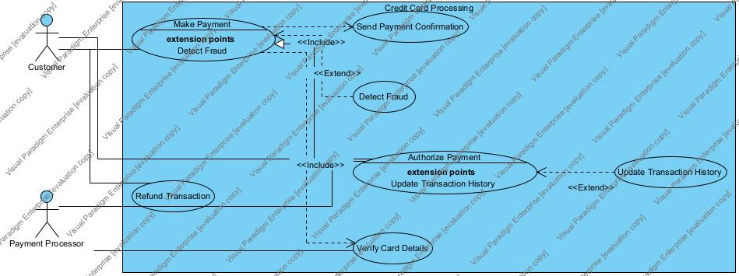

2.2 Class Diagram

Classes

Customer
- customerID
- name
- email
- password
Methods:
- login()
- makePayment()

CreditCard
- cardNumber
- cvv
- expiryDate
- creditLimit
Methods:
- validateCard()

Transaction
- transactionID
- amount
- status
- date
Methods:
- processTransaction()

Merchant
- merchantID
- merchantName

Admin
- adminID
- manageUsers()
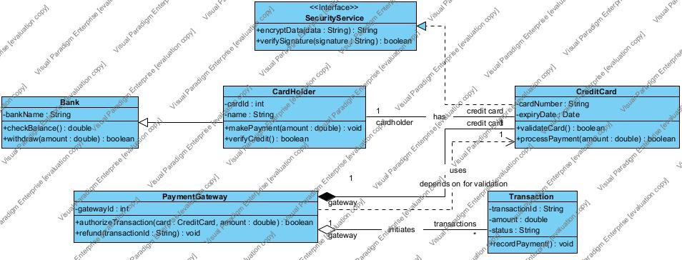

2.3 Sequence Diagram

Payment Process
Customer → System: Enter card details
System → Bank Server: Verify card
Bank Server → System: Valid/Invalid
System → Customer: OTP Request
Customer → System: Submit OTP
System → Bank: Process payment
Bank → System: Success
System → Customer: Payment Confirmation
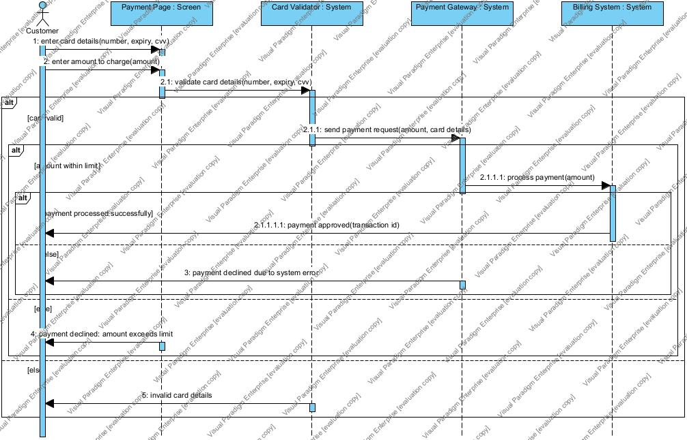

2.4 Context Model
Customer ↔ Credit Card Processing System ↔ Bank
Merchant ↔ System
Admin ↔ System

2.5 Data Model (ER Diagram)

Entities:
- Customer
- CreditCard
- Transaction
- Merchant
- Admin

Relationships:
- Customer owns CreditCard
- Customer performs Transaction
- Merchant receives Transaction
ER Structure:
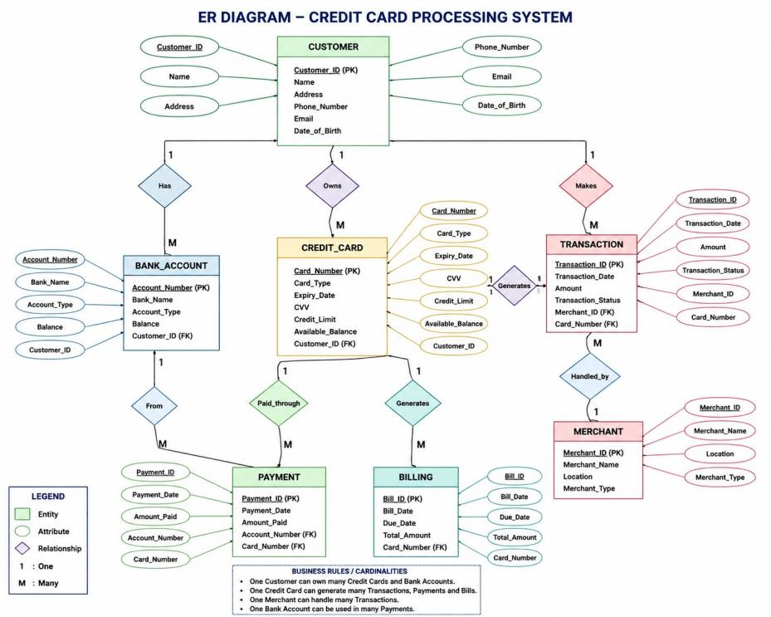

3. Design Engineering

3.1 Software Architecture

Layered Architecture
Presentation Layer
↓
Business Logic Layer
↓
Database Layer

Explanation

Presentation Layer
Handles UI screens.

Business Logic Layer
Processes payment rules and validations.

Database Layer
Stores customer and transaction records.

3.2 Architectural Pattern

MVC (Model View Controller)

Model
Database operations

View
User interface pages

Controller
Processes requests

Why MVC?
- Easy maintenance
- Better separation of concerns
- Reusable code

3.3 Design Quality Attributes

Scalability
Supports many users simultaneously.

Maintainability
Easy updates and bug fixing.

Security
Encrypted card information.

Reliability
Consistent transaction processing.

4. Process & Risk Management

4.1 Process Model Selected

Agile Model

Justification
- Continuous improvement
- Faster delivery
- Easy requirement changes

4.2 Risk Management (RMMM Plan)
Risk | Probability | Impact | Mitigation
Data breach | High | High | Encryption
Payment failure | Medium | High | Backup servers
Server crash | Medium | High | Cloud backup
Fraud attacks | High | High | Fraud detection
System downtime | Medium | Medium | Monitoring

RMMM Meaning
- Risk Mitigation → Prevent risks
- Risk Monitoring → Observe risks
- Risk Management → Handle risks if they occur

5. Testing Strategy

5.1 Test Plan

Objective
Verify payment processing accuracy and security.

Testing Types
- Unit Testing
- Integration Testing
- System Testing
- Security Testing

5.2 Black Box Testing Examples
Test Case ID | Input | Expected Result
BB01 | Valid card details | Payment success
BB02 | Invalid card number | Error message
BB03 | Wrong OTP | Authentication failed
BB04 | Exceed credit limit | Transaction rejected

5.3 White Box Testing Examples
Test Case | Logic Tested
WB01 | Login condition check
WB02 | Payment authorization path
WB03 | OTP verification loop
WB04 | Fraud detection logic

5.4 Validation & System Testing

Validation Testing
Checks whether system meets user needs.
Example:
- User can successfully complete payment.

System Testing
Tests complete integrated system.
Example:
- End-to-end payment processing.

6. Metrics & Quality

6.1 Software Metrics

1. Code Complexity Metric
Measures code difficulty.

2. Defect Density
Number of defects per module.

3. Test Coverage
Percentage of code tested.

6.2 Quality Assurance Activities
- Requirement review
- Code inspection
- Testing verification
- Security checks

6.3 Review Techniques

Peer Review
Developers review code.

Walkthrough
Team explains system flow.

Inspection
Formal defect identification process.

